Javascript Assessment 4.

1. 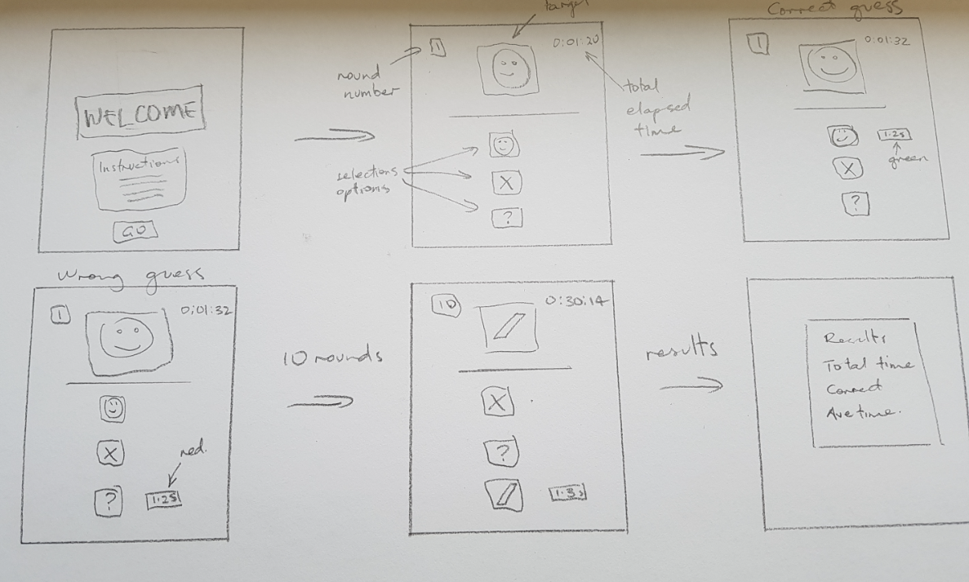
2. entire box – 400px wide, 600px high.

Welcome – 350px wide, 150px high.

Go – 160px wide, 130px high.

Target box – 100px wide, 100px high.

Selection options – 70px wide, 70 px high.

Round number – 100px wide, inherit high.

Total elapsed time - 100px wide, inherit high.

Results – 340px wide, 480 px high.

1. HTML, CSS, Javascript, CSS animation,